

# SCHOOL OF MECHANICAL ENGINEERING

## A PROJECT REPORT ON

“MULTI UTILITY AGRICULTURE VEHICLE”

## Submitted in partial fulfilment of the requirements for the award of the degree of

**BACHELOR OF TECHNOLOGY IN**

**MECHANICAL ENGINEERING**

Submitted by

**OMKAR J PATIL R20ME849**

**RAJASHEKAR.J R20ME856**

**SHARATH.S R20ME875**

**KARTHIK R R14ME071**

Under the guidance of

**MADHU BP**

Assistant Professor

School of Mechanical Engineering REVA University

**2022-2023**

Rukmini Knowledge Park, Kattigenahalli, Yelahanka, Bengaluru-560064 [www.reva.edu.in](http://www.reva.edu.in/)

DECLARATION

### We, Mr. OMKAR J PATIL, Mr. RAJASHEKAR.J, Mr. SHARATH.S, Mr. KARTHIK R

students of B. Tech belonging to School of Mechanical Engineering, REVA University, declare that this Project Report entitled **“MULTI UTILITY AGRICULTURE VEHICLE”** is the project work done by us under the supervision of **Prof. MADHU BP** at School of mechanical Engineering, REVA University.

We are submitting this Project Report in partial fulfilment of the requirements for the award of the degree of Bachelor of Technology in Mechanical Engineering by the REVA University, Bengaluru during the academic year 2021-2023

I declare that this project report satisfies the academic requirements in respect of Project work prescribed for the said Degree.

I further declare that this project report or any part of it has not been submitted for award of any other Degree / Diploma of this University or any other University/ Institution.

*(Signature of the candidates) Signed by us on:*

*Certified that this project work submitted by Omkar J Patil, Rajashekar.J,Sharath.S, Kartik R, has been carried out under my guidance and the declaration made by the candidate is true to the best of my knowledge.*

*Signature of Guide Date: ……….*

*Signature of Director Date: ……….*



### SCHOOL OF MECHANICAL ENGINEERING

**CERTIFICATE**

This is to certify that the project work entitled **“MULTI UTILITY AGRICULTURE VEHICLE”** carried out by **Mr**. **OMKAR J PATIL(R20ME849), Mr. RAJASHEKAR. J(R20ME856), Mr. SHARATH.S(R20ME875), Mr. KARTHIK K(R14ME071)**, are bonafide students of REVA University during the academic year 2022-2023, are submitting the project report in partial fulfilment for the award of **Bachelor of Technology** in Mechanical Engineering during the academic year **2022-2023**. The project report has been approved as it satisfies the academic requirements in respect of Project work prescribed for the said Degree.

**Signature of guide with date Signature of director with date**

### Prof.MADHU B P Dr. K S NARAYANASWAMY

**Asst. Professor, Director**

**School of Mechanical Engineering School of Mechanical Engineering**

**REVA University REVA University**

**Signature of Chancellor with date**



**Dr. P SHYAMA RAJU**

**Name of the Examiner with affiliation Signature with Date**

1.



2.



# ACKNOWLEDGEMENT

We are extremely grateful to **Prof. MADHU B P**, assistant professor school of Mechanical Engineering REVA University, for guiding me throughout the project amidst his tight schedule.

We are extremely thankful to **Dr. K S Narayanaswamy**, Director School of mechanical Engineering REVA University, for his constant encouragement, direction and support throughout the course.

We express our deepest gratitude and thanks to **Dr. P Shyama Raju,** chancellor, REVA University, for providing us an opportunity to complete our education in this auspicious university.

We are grateful to our parents and all members of family for their constant encouragement given to us. We also thank our friends for their cooperation.

Above all, we thank the almighty, for giving us the resource and strength to do this project.

Omkar J Patil – (R20ME849)

Rajashekar.J– (R20ME856)

Sharath.S – (R20ME875)

Karthik R – (R14ME071)

The objective of this paper is to develop "Multi- Utility Agriculture Vehicle. India has always been known for its agricultural products and quality, plus it is one of the key drivers of Indian economy. But since most of the farmers are poor and have smaller farms, there is a need to develop a portable agricultural vehicle which is affordable even for the poor farmers. Also the present agricultural vehicles which are developed have only single functionality i.e. either only seed sowing or water/fertilizer spraying or only ploughing mechanism. The main components of the vehicle are solar panel, battery, DC motor, centrifugal pump. The function of this agricultural vehicle depends on the amount of solar energy that the solar panel receives and this solar energy is used to drive the different parts of the vehicle. The crystal based solar panel is use to charge a rechargeable battery of 12 volts. From the battery the stored electrical energy is sent to DC motor which is used to drive it. The motor converts electrical energy to mechanical energy and this energy is used to perform different operations like water spraying, ploughing, seed sowing with the help of switch control mechanism. The power transmission is done by using various gear mechanisms such as simple spur gear and worm and spur gear mechanisms along with chain and sprocket mechanism. This vehicle reduces the human effort in the field of agriculture and finds a solution to increase the mechanization in the fields. This vehicle is mainly useful for small size farms in order to increase the productivity. This vehicle runs on solar energy which is renewable and is easily available. As mentioned above it can perform multiple functions like seed sowing, water spraying, ploughing in a cost effective way. This vehicle makes use of different mechanisms like chain-sprocket mechanism and worm and spur gear mechanisms in order to carry out these operations.

# TABLE OF CONTENTS

|  |  |  |
| --- | --- | --- |
| **Chapter No.** | **DESCRIPTION** | **Page No.** |
| 1 | **INTRODUCTION** | 1 |
| Components Used and Specification | 2-12 |
| 2 | **LITERATURE SURVEY** | 13 |
| Objectives | 14 |
| Working mechanisms of arc welding and solar pannel. | 14-19 |
| 3 | **METHODOLOGY** | 20 |
| 4 | **DESIGN AND CALCULATION** | 21-29 |
| Designs (2D Model) ,(3D model) and Analysis. |  |
| Calculation | 30-31 |
| 5 | **RESULT, CONCLUSION, FUTURE WORK DISCUSSION AND REFERENCE** |  |
| Result | 32 |
|  | Conclusion | 32-33 |
|  | Future work discussion | 33 |
|  | Cost details | 34 |
| 6 | **REFERENCES** | 35 |

**CHAPTER 1**

1. **INTRODUCTION**

India is an agriculture based country in which, 70% of people depends on the outcome of farming. The written history of agriculture in India dates back to the Rig-Veda. India ranks second worldwide in farm output. Still, agriculture is demographically the broadest economic sector and plays a significant role in the overall socio- economic fabric of India. In recent years if we compare production rate or efficiencies of Indian farms to other nations then we realize India certainly lagging behind. The main reasons for India to lag behind in the development in the field of agriculture are: Lack of proper mechanization in the farms, Smaller size of farms, Financially poor

background of many farmers, Excess efforts required in performing various processes separately, Excess time required for performing individual processes separately, Unorganised farmlands in India. Because the consequence of the above mentioned problems, many farmers cannot afford to purchase heavy agricultural machines (vehicles) due to smaller size of lands and financial constraints. Also, the conventional equipments and methods often require lot of human effort and multiple operations. Thus, agricultural mechanization is a necessary concept to improve the efficiency and reduce the cost of production.

Multifunctional agricultural vehicle deals with the problems faced by farmers i.e. seed sowing, fertilizers spraying, cultivation and digging. We are looking this project as revolution in small farms in India, which is most uncovered area in this sector, in a cost effective and more efficient way. These vehicles are capable of working 24 hours a day all year round, in most weather conditions. Moreover such a system may have less environmental impact if it can reduce over application of chemicals and high usage of energy, such as diesel and fertilizer, by control that is better matched to stochastic requirements. The inclusion of the solar panels to charge the battery and run the vehicle is also an added advantage by reducing the usage of fossil fuels.The main components of the vehicle are solar panel, battery, DC motor, centrifugal pump. The function of this agricultural vehicle depends on the amount of solar energy that the solar panel receives and this solar energy is used to drive the different parts of the vehicle. The crystal based solar panel is use to charge a rechargeable battery of 12 volts. From the battery the stored electrical energy is sent to DC motor which is used to drive it. The motor converts electrical energy to mechanical energy and this energy is used to perform different operations like water spraying, ploughing, seed sowing with the help of switch control mechanism. The power transmission is done by using various gear mechanisms such as simple spur gear and worm and spur gear mechanisms along with chain and sprocket mechanism. Our model is designed in such a manner so that it can be run even in small farms and performs the various operations like digging and ploughing, water sprinkling, and seed sowing effectively.

**COMPONENTS USED AND SPECIFICATION:**

1. **Chain system**

Fig. 1: Chain system

A bicycle chain is a [roller chain](https://en.wikipedia.org/wiki/Roller_chain) that transfers [power](https://en.wikipedia.org/wiki/Power_(physics)) from the [pedals](https://en.wikipedia.org/wiki/Bicycle_pedal) to the drive-[wheel](https://en.wikipedia.org/wiki/Bicycle_wheel) of a [bicycle](https://en.wikipedia.org/wiki/Bicycle), thus propelling it. Most bicycle chains are made from [plain carbon](https://en.wikipedia.org/wiki/Steel) or [alloy steel](https://en.wikipedia.org/wiki/Alloy_steel), but some are [nickel-plated](https://en.wikipedia.org/wiki/Nickel_electroplating) to prevent rust, or simply for aesthetics.

A bicycle chain can be very energy efficient: one study reported efficiencies as high as 98.6%. The study, performed in a clean laboratory environment, found that efficiency was not greatly affected by the state of lubrication. A larger sprocket will give a more efficient drive because it moves the point of pressure farther away from the axle, placing less stress on the bearings, thus reducing friction in the inner wheel. This is actually not in the direction you'd expect, based simply on friction"

1. **Handle**

Fig.2: Handle

A handle is a part of, or attachment to, an object that allows it to be [grasped](https://en.wikipedia.org/wiki/Grasp) and [manipulated](https://en.wikipedia.org/wiki/Object_manipulation) by [hand](https://en.wikipedia.org/wiki/Hand). The design of each type of handle involves substantial [ergonomic](https://en.wikipedia.org/wiki/Ergonomics) issues, even where these are dealt with intuitively or by following tradition. Handles for [tools](https://en.wikipedia.org/wiki/Tools) are an important part of their function, enabling the user to exploit the tools to maximum effect. [Package handles](https://en.wikipedia.org/wiki/Package_handle) allow for convenient carrying of packages.

1. **Seat**

Fig.3: Seat

A bicycle saddle, often called a bicycle seat, is one of five contact points on an [upright bicycle](https://en.wikipedia.org/wiki/Upright_bicycle), the others being the two [pedals](https://en.wikipedia.org/wiki/Bicycle_pedal) and the two handles on the [handlebars](https://en.wikipedia.org/wiki/Bicycle_handlebar). (A [bicycle seat](https://en.wikipedia.org/wiki/Bicycle_seat) in the specific sense also supports the back.) The bicycle saddle has been known as such since the [bicycle](https://en.wikipedia.org/wiki/Bicycle) evolved from the [draisine](https://en.wikipedia.org/wiki/Draisine), a forerunner of the bicycle.[[2]](https://en.wikipedia.org/wiki/Bicycle_saddle#cite_note-2)[[3]](https://en.wikipedia.org/wiki/Bicycle_saddle#cite_note-3) It performs a similar role as a horse's [saddle](https://en.wikipedia.org/wiki/Saddle), not bearing all the weight of the rider as the other contact points also take some of the load.

Hardshell seats are normally made of a composite material such as GRP or carbon fibre although metal and wood versions do exist. A hardshell seat is normally covered with some-form of padding, this is usually closed or open cell foam although some extreme racing machines do not have any padding on the seat to reduce weight and increase efficiency. Hardshell seats are generally used at more reclined angles than mesh seats.

Some riders complain of excessive road noise vibrating through the hardshell seat. Also, the hardshell seat is "closed", providing no ventilation, which may cause excessive sweat to build up on the cyclist's back on hot days.

1. **Battery**

Fig.4: Battery

A battery is a source of [electric power](https://en.wikipedia.org/wiki/Electric_power) consisting of one or more [electrochemical cells](https://en.wikipedia.org/wiki/Electrochemical_cell) with external connections for powering [electrical](https://en.wikipedia.org/wiki/Electricity) devices. When a battery is supplying power, its positive terminal is the [cathode](https://en.wikipedia.org/wiki/Cathode) and its negative terminal is the [anode](https://en.wikipedia.org/wiki/Anode). The terminal marked negative is the source of electrons that will flow through an external electric circuit to the positive terminal. When a battery is connected to an

external electric load, a [redox](https://en.wikipedia.org/wiki/Redox) reaction converts high-energy reactants to lower-energy products, and the [free-energy](https://en.wikipedia.org/wiki/Gibbs_free_energy) difference is delivered to the external circuit as electrical energy. Historically the term "battery" specifically referred to a device composed of multiple cells; however, the usage has evolved to include devices composed of a single cell.

1. **Sowing seeds**

Fig.5: Sowing seeds

Sowing is the process of planting seeds. An area or object that has had seeds planted in it will be described as a sowed or sown area.

* Sowing is the most important part of crop production. Before sowing, good quality seeds are selected.
* Traditional tool: The tool used traditionally for sowing seeds is shaped like a funnel. The seeds are filled into the funnel, passed down through two or three pipes having sharp ends. These ends pierce into the soil and place seeds there.
* Seed drill: Nowadays the seed drill is used for sowing with the help of tractors. This tool sows the seeds uniformly at proper distances and depths. It ensures that seeds get covered by the soil after sowing. This prevents damage caused by birds. Sowing by using a seed drill saves time and labour.

Sowing types and patterns

For hand sowing, several sowing types exist; these include.

* Flat sowing
* Ridge sowing
* Wide bed sowing
* Rows that are indented at the even rows (so that the seeds are
* Symmetrical grid pattern – using the pattern described in [The Garden of Cyrus](https://en.wikipedia.org/wiki/The_Garden_of_Cyrus) placed in a crossed pattern). This method is much better, as lighter may fall on the seedlings as they come out.

1. **Ploughing**

Fig.6: Ploughing

A plough or plow is a farm tool for loosening or turning the soil before sowing seed or planting. Ploughs were traditionally drawn by oxen and horses but in modern farms are drawn by tractors. A plough may have a wooden, iron or steel frame, with a blade attached to cut and loosen the soil.

The prime purpose of ploughing is to turn over the uppermost soil, bringing fresh [nutrients](https://en.wikipedia.org/wiki/Plant_nutrients_in_soil) to the surface while burying [weeds](https://en.wikipedia.org/wiki/Weed) and crop remains to [decay](https://en.wikipedia.org/wiki/Decomposition). Trenches cut by the plough are called furrows. In modern use, a ploughed field is normally left to dry and then [harrowed](https://en.wikipedia.org/wiki/Harrow_(tool)) before planting. Ploughing and [cultivating](https://en.wikipedia.org/wiki/Tillage) soil evens the content of the upper 12 to 25 centimetres (5 to 10 in) layer of soil, where most plant feeder [roots](https://en.wikipedia.org/wiki/Root) grow.

1. **Water Sprinkler**

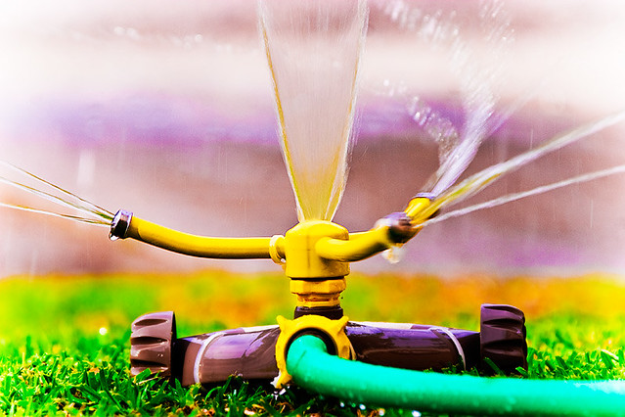

Fig.7:Water Sprinkler

An irrigation sprinkler (also known as a water sprinkler or simply a sprinkler) is a device used to [irrigate](https://en.wikipedia.org/wiki/Irrigation) (water) agricultural crops, lawns, landscapes, golf courses, and other areas. They are also used for cooling and for the control of airborne dust. Sprinkler irrigation is the method of applying water in a controlled manner in way similar to rainfall. The water is distributed through a network that may consist of pumps, valves, pipes, and sprinklers.

Irrigation sprinklers can be used for residential, industrial, and agricultural usage. It is useful on uneven land where sufficient water is not available as well as on sandy soil. The perpendicular

pipes, having rotating nozzles on top, are joined to the main pipeline at regular intervals. When water is pressurized through the main pipe it escapes from the rotating nozzles. It gets sprinkled on the crop. In sprinkler or overhead irrigation, water is piped to one more central location within the field and distributed by overhead high pressure sprinklers or guns.

1. **Tire**

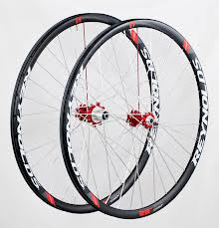

Fig.8:Tire

A tire is a ring-shaped component that surrounds a [wheel's rim](https://en.wikipedia.org/wiki/Rim_(wheel)) to transfer a vehicle's load from the [axle](https://en.wikipedia.org/wiki/Axle) through the wheel to the ground and to provide [traction](https://en.wikipedia.org/wiki/Traction_(engineering)) on the surface over which the wheel travels. Most tires, such as those for automobiles and bicycles, are [pneumatically](https://en.wikipedia.org/wiki/Pneumatic) inflated structures, which also provide a flexible cushion that absorbs shock as the tire rolls over rough features on the surface. Tires provide a footprint, called a [contact patch](https://en.wikipedia.org/wiki/Contact_patch), that is designed to match the weight of the vehicle with the bearing strength of the surface that it rolls over by providing a bearing pressure that will not deform the surface excessively.

The materials of modern pneumatic tires are [synthetic rubber](https://en.wikipedia.org/wiki/Synthetic_rubber), [natural rubber](https://en.wikipedia.org/wiki/Natural_rubber), fabric, and wire, along with [carbon black](https://en.wikipedia.org/wiki/Carbon_black) and other chemical compounds. They consist of a [tread](https://en.wikipedia.org/wiki/Tire_tread) and a body. The tread provides [traction](https://en.wikipedia.org/wiki/Traction_(engineering)) while the body provides containment for a quantity of [compressed air](https://en.wikipedia.org/wiki/Compressed_air). Before [rubber](https://en.wikipedia.org/wiki/Rubber) was developed, the first versions of tires were simply bands of metal fitted around wooden wheels to prevent wear and tear. Early rubber tires were solid (not pneumatic). Pneumatic tires are used on many types of vehicles, including [cars](https://en.wikipedia.org/wiki/Car), [bicycles](https://en.wikipedia.org/wiki/Bicycle), [motorcycles](https://en.wikipedia.org/wiki/Motorcycle), [buses](https://en.wikipedia.org/wiki/Bus), [trucks](https://en.wikipedia.org/wiki/Truck), [heavy equipment](https://en.wikipedia.org/wiki/Heavy_equipment_(construction)), and [aircraft](https://en.wikipedia.org/wiki/Aircraft). Metal tires are still used on [locomotives](https://en.wikipedia.org/wiki/Locomotive) and [railcars](https://en.wikipedia.org/wiki/Railcar), and solid rubber (or other polymers) tires are still used in various non-automotive applications, such as some [casters](https://en.wikipedia.org/wiki/Caster), [carts](https://en.wikipedia.org/wiki/Cart), [lawnmowers](https://en.wikipedia.org/wiki/Lawn_mower), and [wheelbarrows](https://en.wikipedia.org/wiki/Wheelbarrow).

1. **Solar panel**

Fig.9: Solar Panel

This energy creates electrical charges that move in response to an internal electrical field in the cell, causing electricity to flow.The amount of sunlight that strikes the earth's surface in an hour and a half is enough to handle the entire world's energy consumption for a full year. Solar technologies convert sunlight into electrical energy either through photovoltaic (PV) panels or through mirrors that concentrate solar radiation. This energy can be used to generate electricity or be stored in batteries or thermal storage.

The amount of sunlight that strikes the earth's surface in an hour and a half is enough to handle the entire world's energy consumption for a full year. Solar technologies convert sunlight into electrical energy either through photovoltaic (PV) panels or through mirrors that concentrate solar radiation. This energy can be used to generate electricity or be stored in batteries or thermal storage.

1. **[Electric Wire](https://www.amazon.in/Electric-Wire/s?k=Electric+Wire)**

**[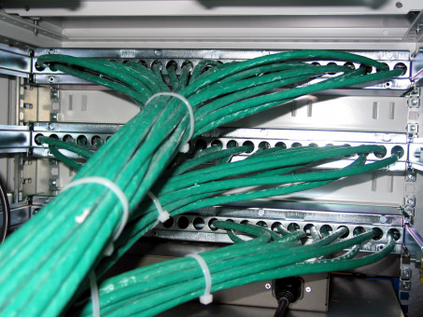](https://www.amazon.in/Electric-Wire/s?k=Electric+Wire)**

Fig.10: Electric Wire

Electrical wire is typically made of copper or aluminum, and these conductive materials are insulated as wires that bring electricity to various parts of your home.

When you're installing new wiring, [choosing the right wire](https://www.thespruce.com/choosing-electrical-wire-gauge-amperage-3969938) or cable is half the battle. On the other hand, when examining the [old wiring](https://www.thespruce.com/is-my-old-house-wiring-safe-1152890) in your home, identifying the wire type can tell you a lot about the circuit the wiring belongs to (for example, if you open a junction box and need to determine which wires go where). Wiring for modern homes is quite standard, and most homes built after the mid-1960s have similar types of wiring. Any new electrical installation requires new wiring that conforms to local building codes.

1. **Nut**

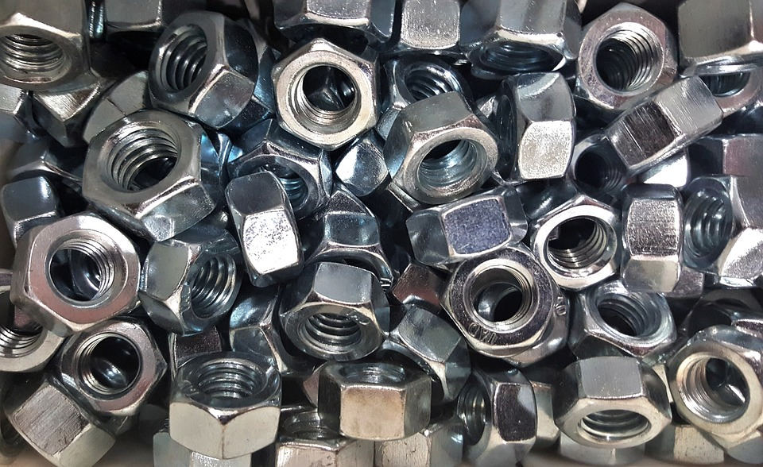

Fig.11: Nut

A nut is a small metal object with a hole in the middle that has corrugated hole. These curved holes are known as threads. Nuts are used as a fastening device. It is important to note that evens though nuts are used as a fastening device, they cannot be used without bolts. To understand this, we have to understand the shape of walnuts. The outer part of its body can be shaped either way, but it is mostly hexagonal cap or circular in shape.

The inside shape is always circular; this is because this is where the bolt stem fits, and the bolt stem is always cylindrical in shape so that it can rotate easily and fit into the threads. The two partners (i.e., nuts and bolts) are held together by a combination of friction of their thread, a slight stretch of the bolt, & compression of the part to join together. The nuts come with a separate locking mechanism that prevents machine parts from loosening due to the vibration of the parts or parts that they joined. They are mostly of a circular cross-section.

1. **Bolts**

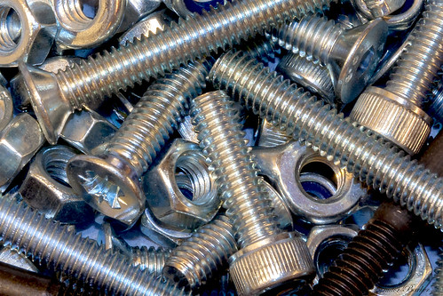

Fig.12: Bolts

Bolts are metal objects consisting of a cylindrical trunk with grooves such as grooves that are similar to the grooves present inside a nut. In addition to this threaded stem, there is also a forward current, which helps hold the fasten together. As stated in the paragraph above, a bolt goes into a hole in a circular thread of a nut, where the bolt grooves fit perfectly with the nut grooves. Then, at rotational speed, the bolt nut is able to move the bolt up and over.

Some bolts have this threaded nature with their trunk; some have only the last part of its stem. There is no clear distinction between bolts & nuts, and one can easily get confused between them, but standardly, the bolts do not pass through a threaded area and are fastened with the help of bolts; however, Used for components that have already been damaged.

**CHAPTER 2**

**LITERATURE SURVEY**

* Sahu et al.[1] In 2018 conducted a study on the development of a multi-utility agricultural vehicle equipped with a rotary tiller and a seed drill. The vehicle was designed to be cost-effective and efficient for small-scale farmers in India. The study found that the vehicle was effective in reducing labor requirements and improving crop yields.
* Patil et al. [2]. In 2019, published a research article on the design and development of a multi-utility agricultural vehicle with a modular platform. The vehicle was designed to be versatile and adaptable for different farming operations, such as plowing, sowing, and harvesting. The study found that the vehicle was effective in improving productivity and reducing operational costs.
* Adeyemo et al[3]. In 2020 on the design and development of a multi-utility agricultural vehicle for soil cultivation and fertilization. The vehicle was equipped with a cultivator and a fertilizer applicator, and was designed to be suitable for smallholder farmers in Africa. The study found that the vehicle was effective in improving soil health and crop yields.
* Wang et al. [4]. In 2021, conducted a study on the development of a multi-utility agricultural vehicle for greenhouse cultivation. The vehicle was equipped with a planting robot and a pest control system, and was designed to be suitable for greenhouse farming operations. The study found that the vehicle was effective in improving productivity and reducing labor requirements.
* Prasad et al. [5]. In 2022, published a research article on the design and development of a multi-utility agricultural vehicle with a hybrid power system. The vehicle was equipped with both an electric motor and an internal combustion engine, and was designed to be efficient and environmentally friendly. The study found that the vehicle was effective in reducing emissions and improving fuel efficiency.
* Kulkarni et al. [6]. In 2018, on the design and development of a multi-utility agricultural vehicle for smallholder farmers in India. The vehicle was designed to perform functions such as plowing, tilling, and sowing, and was equipped with features such as a seed drill and a spray tank. The study found that the vehicle was an efficient and cost-effective solution for smallholder farmers.
* Mishra et al [7]. In 2019, on the design and development of a multi-utility agricultural vehicle for sustainable farming practices. The vehicle was equipped with features such as solar panels and electric motors to reduce its carbon footprint. The study found that the vehicle was effective in reducing the environmental impact of farming operations while improving productivity.
* Reddy et al [8].In 2020 the study was on the design and development of a multi-utility agricultural vehicle for precision farming. The vehicle was equipped with sensors and GPS technology to enable precision planting and fertilization. The study found that the vehicle was effective in improving the accuracy and efficiency of farming operations.
* Mwongera et al.[9] In 2021, the study was conducted on the design and development of a multi-utility agricultural vehicle for smallholder farmers in Africa. The vehicle was designed to perform functions such as plowing, harrowing, and planting, with a low power requirement. The study concluded that the vehicle was a promising solution for improving agricultural productivity and livelihoods in rural areas.
* Vinothkumar et al.[10].In 2022 the study was conducted on the design and development of a multi-utility agricultural vehicle for sustainable weed management. The vehicle was equipped with features such as a mechanical weeder and a thermal weed control system. The study found that the vehicle was effective in reducing weed growth and improving crop yields.

# OBJECTIVES

* + The main objective of this project is to help farmers in the forming.
  + This project lets farmers to harvest easily without any effort.
  + We can reduce the emissions caused by the usage of fossil fuels by utilizing solar energy.
  + It will reduce the cost of seed feeding, pesticides sprinkling and crop cutting the field and will help to increase economic standard of an Indian farmer.
  + The aim of designing the system is to provide an manually operated machine with reliable monitoring, safety, better efficiency and reduced environment impact.
  + Finally by minimizing the human work force required for forming.
  + The vehicle is powered by solar energy,By collecting the energy from sun and storing in the battery.

Working mechnisms arc welding:-

**Arc welding:**

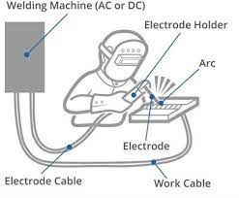

Fig.13: Arc Welding

Arc welding is a type of welding process using an electric arc to create heat to melt and join metals. A power supply creates an electric arc between a consumable or non-consumable electrode and the base material using either direct (DC) or alternating (AC) currents.

The arc can be either manually or mechanically guided along the line of the join, while the electrode either simply carries the current or conducts the current and melts into the weld pool at the same time to supply filler metal to the join.

Because the metals react chemically to oxygen and nitrogen in the air when heated to high temperatures by the arc, a protective shielding gas or slag is used to minimise the contact of the molten metal with the air. Once cooled, the molten metals solidify to form a metallurgical bond.

**Types of materials used in Arc Welding:**

**Electrode holder clamp:**

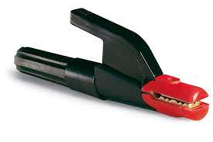

Fig.14:Electrode Holder Clamp

The primary function of the electrode holder clamp is to support the electrode, guaranteeing a good electrical contact for current passage; it should also guarantee sufficient electrical insulation for the welding operator.

**Coated electrodes:**

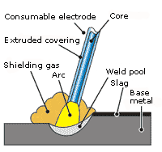

Fig.15: Coated electrodes

The coated electrode consists of a core and a coating which have different but complementary functions: the core acts mainly as a conductor for the arc power supply and as supplier of the material that fills the joint; the coating, on the other hand, has the main function to protect the weld pool and stabilise the arc.

A coated electrode is made of a metallic wire (called core wire) coated uniformly with flux material. While fluxing, the electrode about 20 mm of its length is left bare at one end for mounting it into the electrode holder. The flux material used for coating of the electrode is a bad conductor of electricity.

**Advantage of arc welding:**

* **High welding speed** – Arc welding is a fast-welding process, making it suitable for high production rates and large-scale projects.
* **Versatility** – Arc welding can be used on a wide range of materials, including steel, aluminum, and cast iron, making it a versatile method for welding different materials.
* **Deep penetration** – Arc welding has the ability to create deep, strong welds due to the high heat and intensity of the arc.
* **Economical** – Arc welding is an economical option, as it is relatively inexpensive and requires fewer raw materials compared to other welding processes.
* **Portable** – Arc welding equipment is portable and can be easily transported to different locations, making it suitable for use in various settings.

**Disadvantage of arc welding:**

* **Health hazards** – Arc welding can produce harmful fumes and radiation, making it necessary for welders to use protective equipment to reduce the risk of injury.
* **High initial cost** – Arc welding equipment can be expensive, particularly for specialized processes, making it a costly option for some individuals or organizations.
* **Requires skilled labor** – Arc welding requires a certain level of skill and training, making it necessary to hire or train specialized personnel.
* **Limited suitability for certain materials** – Arc welding may not be suitable for certain materials, such as those that are brittle or prone to cracking, or for thin materials that may be distorted by the heat of the welding process.
* **Limited accessibility** – Arc welding equipment and facilities may not be readily accessible or available to all individuals or organizations.

**Working mechanisms solar pannel :-**

**Conversion solar energy into electrical energy:**

Fig.16:Solar panel

Solar panels are responsible for generating electricity and in most cases they are located on the roof of any building. Hence it is through these solar panels where the real story begins and solar energy gets converted into electricity. These solar panels also known as the modules are usually southern faced for maximum potential and electricity production.

Each of these solar panels is made up of a special layer of silicon cells, a metal frame, a glassed casing which is further surrounded by special film and wiring. For maximum electricity production, the solar panels are arranged together into "arrays". This through these solar cells also known as photovoltaic cells, where the sunlight is absorbed during the daylight hours.

**Conversion of absorbed solar energy into electrical energy**

* Photovoltaic meaning light and electricity and hence installing these solar cells or photovoltaic cells is the first initial step to convert solar energy.
* Each Solar cell has a thin semiconductor wafer which is made up of two layers of silicon. Now silicon is a naturally occurring chemical element, one of the greatest semiconductors. Silicon semiconductors can act as both conductors as well as insulators.
* One silicon layer is positively charged known as the N-type and the other silicon layer is negatively charged known as the P-type. N-type gives away electrons easily while on the other side P-side semiconductor receives the extra electrons in the electric field. This positive and negative layer hence compliments the formation of an electric field on the solar panel.
* We all know that energy from the sun comes on the earth in the form of little packets called photons When the sunlight strikes these photovoltaic cells already forming an electric field, the photons of sunlight startle the electrons inside these cells activating them to start flowing.
* These loose electrons that start flowing on the electric field further create the electric current.

**How electrical energy gets converted for usage**

The electrical energy which we get from the solar energy through the photovoltaic cells is normally known as the Direct current (DC) electricity. But this direct current electricity cannot be used to power homes and buildings, therefore to utilize this generated electrical energy, we need to convert it into Alternating current (AC) electricity.

Further to convert Direct current into alternating current special solar inverters need to be installed. In modern solar systems, these investors can be configured as one of the inverters for the entire system, or micro-mini inverters need to be attached behind the panels. The inverter turns DC electricity to 120 volts AC that can be further put into immediate use for the home appliances. The power produced by solar energy initially passes through the electrical panel in your home and then passes out into the electric grid. When in the case your solar plant is generating more electricity than your immediate consumption, your utility meter will turn backward.

Once your DC gets converted to AC, the current then runs through your electrical panel installed in your home and hence supplies power to all the home appliances. The electricity generated in the solar power system is the same power generated through the grid by your electric utility company; therefore no changes in the home are required to get power from solar energy.

**Working:**

* The Multi utility vehicle works based on the principal of pedaling force
* This multi utility vehicle is mainly focused To perform certain Agricultural tasks such as ploughing sowing and water dispensing
* The multi utility vehicle functions based on human effort by pedaling the multi utility vehicle. By pedaling the wheels are interlinked to the seed dispenser with the help of chain sprocket system.
* By performing this process of motion, the soil gets ploughed, and the seed gets dispensed into the grooved soil path simultaneously.
* After the process of seed dispensing, we have included water spraying where in which the water gets sprayed on the soil surface.
* This water sprinkler works based on the renewable energy that is the solar energy which gets converted into electrical energy that helps the water pump to perform water sprinkling

# CHAPTER 3

**METHODOLOGY**

**CHAPTER-4**

**DESIGN,** **ANALYSIS AND CALCULATION**

**Designs (2D Model)**

Fig.17: Top view

Fig.18:Side view

**Designs (3D Model)**

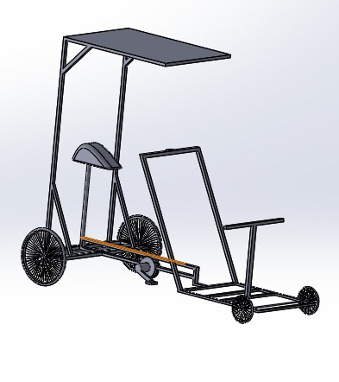

Fig.19:Isometric view

Fig.20:Rear isometric view

Fig.21: Front View

Fig.22: Side View

**ANALYSIS**

Fig.23:Bending Moment

The bending moment of the multi utility vehicle is as shown in the above figure

The loads are acting on the three points of the frame

The maximum bending moment obtained is 28088 N-MM

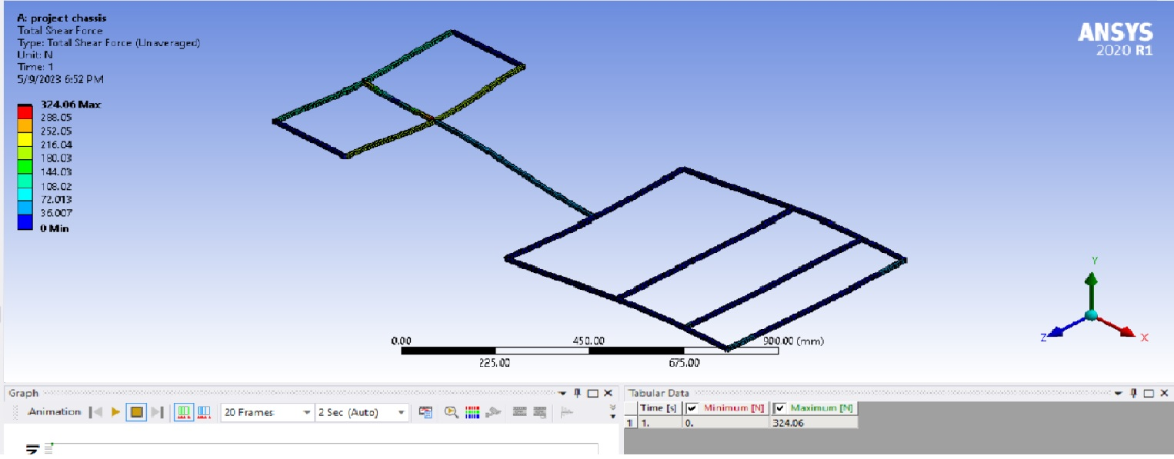

Fig.24:Shear Force

The shear force of the multi utility vehicle is as shown in the above figure

The maximum shear force obtained by the analysis of the multi utility vehicle is 324.06 N

Fig.25:Total Deformation

The total deformation of the multi utility vehicle is as shown in the above figure

The maximum total deformation obtained by the analysis of the multi utility vehicle is 7.5106 MM

**Final working model**

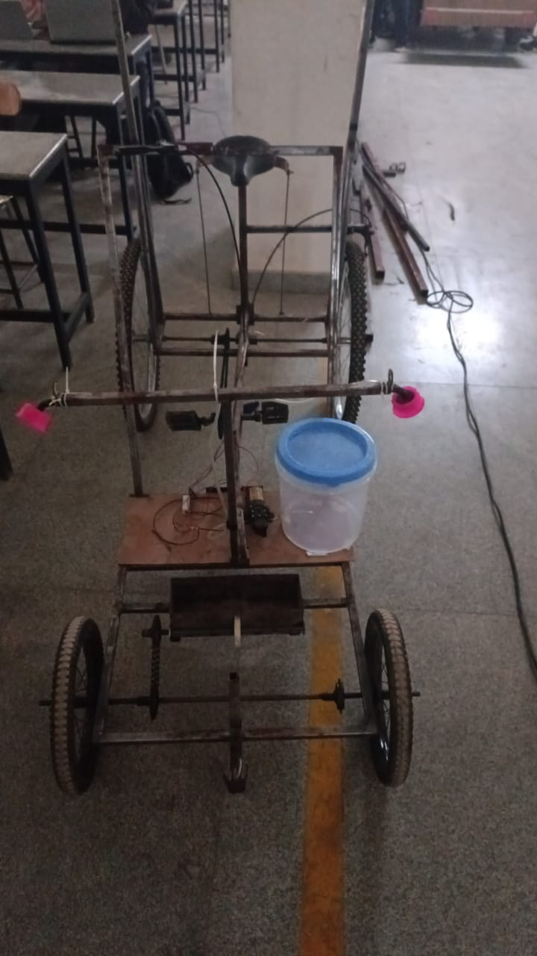

Fig.26: Front view

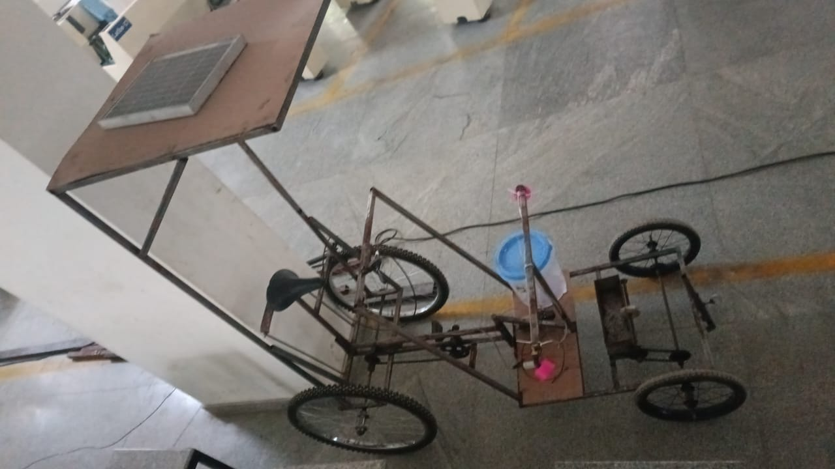

Fig.27:Top view

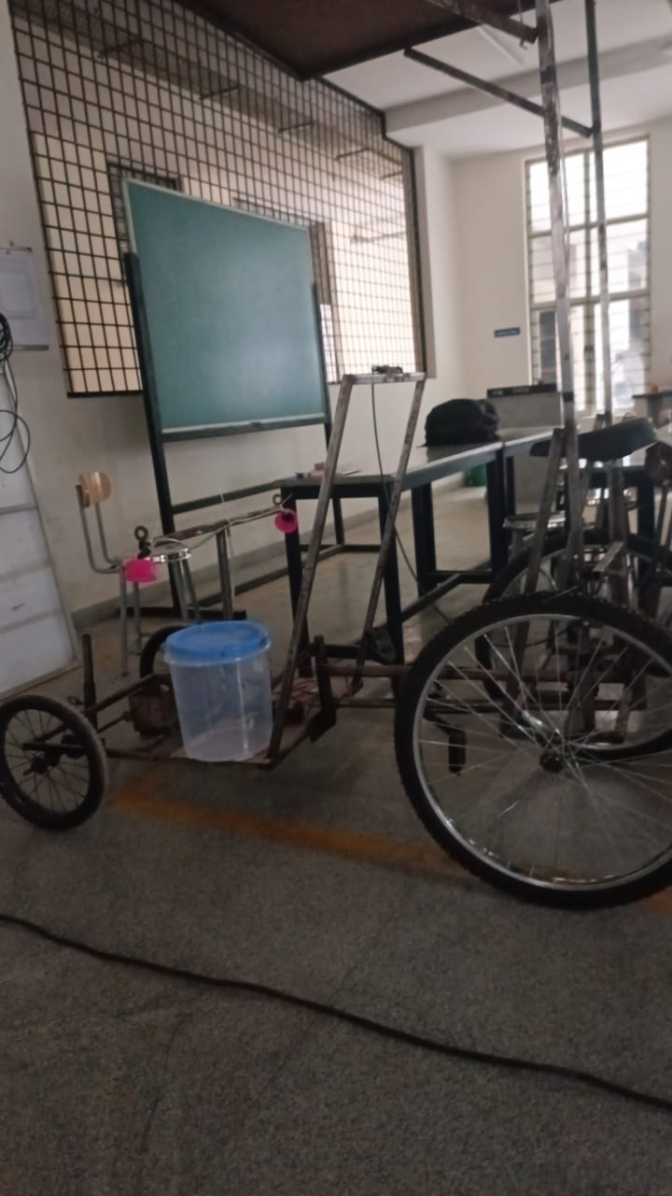

Fig.28: Side view

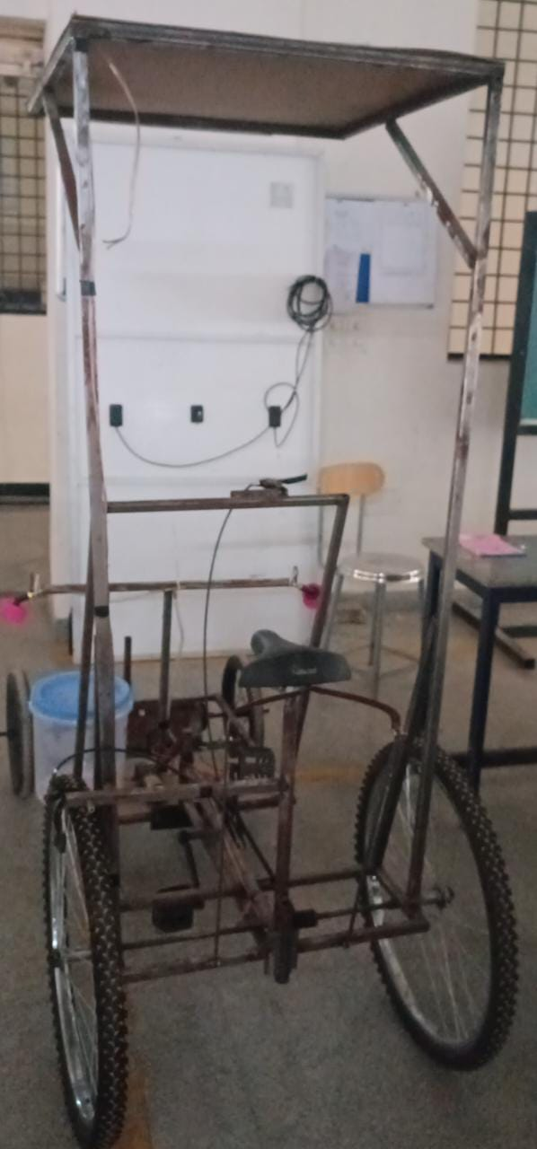

Fig.29: Rear view

# Calculation

Force Calculation

Assuming weight of the machine,

W = 75 kg W = 75x9.81 W = 539.55 N

# Calculation of Battery:

How much time will it take to charge a 10w battery?

4 hours (9V/2A 12V/1.5A charger and supplied cable); approx. 6 hours (5V/2A charger and supplied cable).

According to above assumption

Battery capacity = 7.5Ah

Battery voltage = 12v

With the help of 10w solar panel we get,

10/12A current = 0.833A

so charging time would be 7.5Ah/0.833A = Approx 9 hours.

This is an theoretical assumption. It takes more than this time to charge the battery full of rating 7.5Ah with 10w solar panel as while charging always there is power loss.

# Calculation of Pedaling Force:

Power = force × velocity.

Force of a pedalling applied by a human for achieving 30.4 kph = 183/8.44 = 21.68 newtons.

This is for upright bicycles.

Recumbents are more efficient.

For 70 kph a highly efficient aero dynamic recumbent needs 400 watts.

Thats 13.09 newtons...!!

Power output varies considerably with the individual. Professional cyclists will sustain 200–300 W, but let’s take a “pretty good” cyclist at 150 W. Source: Why smart cyclists train with watts

Cadence also varies, but apparently the optimal cadence for sustained effort is around 80 rpm. This is a frequency of 1.33 Hz and an angular frequency of 8.38 rad/s. Source: What Should Your Ideal Cadence Really Be?

Cranks length doesn’t vary much. This source says that 165 mm is good: Bike fit variables: No. 2 crank length

The cadence and crank length can be used to determine the speed of the person’s feet using the following relationship for circular motion:

tangential speed = radius * angular velocity = (0.165 meters) * (8.38 rad/s) = 1.38 m/s

The speed of the person’s feet and power output of the person can then be used to determine the force between the person and the pedals (assuming that the force is tangential):

Power = Force * velocity

Force = power/velocity = 150 watts/(1.38 m/s) = 109 newtons = 24.5 lb

Note that this is an average force of the two feet on the pedals. It will be uneven over time and also unevenly distributed between the two feet. This is also a lower limit for these parameters as not everyone will exert forces exactly tangential to the circle. I am guessing that experienced cyclists are more consistent in their forces and more effective at directing the forces of their feet tangentially.

**Calculation for seeding:**

Speed = 6 rpm Row. spacing= 10.9M/Minute.

Seed sowing time= 5 sec/per seed .Opening no. = 5.

Seed dropping per minute = 5*6= 30 seeds.

Hence, If the speed of the wheel is 10.9m/min, then for 10.9 meter 30 seeds will be dropped.

Small chain sprocket = 17 teeths.

Big chain sprocket = 32 teeths.

Rear wheel diameter (D)= 60cm.

Radius (rear wheel)=D/2=30cm.

Front wheel diameter(d)=30cm.

Radius (front wheel)=d/2=15cm.

**CHAPTER-5**

**RESULT, CONCLUSION, FUTURE WORK DISCUSSION AND REFERENCE**

**Result**

* The Multi-Purpose Agriculture Vehicle aims to perform various agricultural operations. The developed model runs successfully performing all the agricultural operations, i.e. ploughing, seed sowing and water spraying both simultaneously and individually with the help of electrical switches.
* Also the use of solar power to run the vehicle is an added advantage being a renewable source of energy. Thus, being a multi-utility vehicle, it has other advantages like reduced manpower, increased rate of productivity and better efficiency as it is battery operated.
* It is cost effective which is affordable even for the poor farmers. Also by the use of effective seeding mechanism, the wastage of the seeds is reduced. The electrical switch mechanism makes it much easy to operate for the farmers.
* The vehicle can also be used for material handling and hence makes it feasible to move heavy loads.

**Conclusion**

* The multi Utility Agriculture Vehicle aims to perform various operations of the agriculture, which are accomplished by using various components like solar panel, mini water pump, and motion transmission mechanisms.
* The various components required for building the multipurpose agricultural equipment has been designed as planned.
* Multi Utility agricultural vehicle is single system which can perform multi operations like sowing, water spraying, ploughing . It can also be used for local transportation purpose for material handling.
* Multi Utility agricultural vehicle will reduce external charges like fuels; electricity etc. and this will be helpful for poor farmers.
* Multi Utility agricultural vehicle is a single system which contains multi attachments. The equipment weight is around 8 to 10 kg thus it can be carried easily in farmland.

**Future work**

* The semi-automatic seed sowing machine is suitable for dry land. It can be modified in such a way that it can be used in wet land also.
* We can change the seeding row distance by providing a C-Clamp to the distribution impellers so that it can be fastened at any distance on the shaft.
* We can change the seeding column distance by replacing the distribution rollers with different groove distance.
* The solar panel can replace the battery power supply to reducing the recharge cost.
* One or more system can be connected to GSM system
* Design and fabrication is done and guideways are completed as per the specification.
* On both side the wheels are been fixed.

|  |  |  |  |
| --- | --- | --- | --- |
| **SL NO** | **TITTLE** | **SPECIFICATION** | **COST** |
| 1. | MAIN FRAME | 19MM SQ PIPE | ₹5000 |
| 2. | DRIVE TYPE | CHAIN DRIVE | ₹2000 |
| 3. | BATTERY | 12V, 7500MAH | ₹2000 |
| 4. | SOLAR PANEL | 12V 10 WATT | ₹2500 |
| 5. | BIG WHEELS | 60CM | ₹300 |
| 6. | SMALL WHEELS | 30CM | ₹250 |
| 7. | MISCELLANEOUS |  | ₹2950 |
| 8. | TOTAL COST |  | ₹15000 |

**Cost Details:**

**References**

1. Sahu, P. K., Jana, A., & Sharma, A. (2018). Design and development of a low-cost multi-utility agricultural vehicle for small-scale farmers in India. Journal of Terramechanics, 76, 1-9.
2. Kulkarni, M., Patil, A., & Patil, M. (2018). Design and Development of Multi-Utility Agricultural Vehicle for Small Farmers. International Journal of Current Engineering and Technology, 8(3), 1167-1171.
3. Patil, S. R., Khutale, S. P., & Patil, S. S. (2019). Design and development of modular multi-utility agricultural vehicle. International Journal of Engineering and Advanced Technology (IJEAT), 8(2), 63-69.
4. Mishra, S. K., Agnihotri, G., Kumar, S., & Kumar, A. (2019). Design and Development of a Multi-Utility Agricultural Vehicle for Sustainable Farming Practices. Journal of Cleaner Production, 222, 424-436.
5. Adeyemo, J. A., Yusuf, R. O., & Odediran, O. O. (2020). Development of a multi-utility agricultural vehicle for soil cultivation and fertilization. International Journal of Agricultural and Biological Engineering, 13(6), 117-124.
6. Reddy, P., Kumar, P., Singh, P., & Poonia, P. (2020). Design and Development of Multi-Utility Agricultural Vehicle for Precision Farming. International Journal of Engineering and Advanced Technology, 9(6), 7746-7751.
7. Wang, C., Zhu, L., Chen, X., Zou, D., & Zhou, C. (2021). Design and experiment of a multi-utility agricultural vehicle for greenhouse cultivation. Transactions of the Chinese Society of Agricultural Engineering, 37(8), 46-53.
8. Mwongera, J. K., Okello, R., Mwakaje, A. G., & Mcharo, M. (2021). Design and Development of a Multi-Utility Agricultural Vehicle for Smallholder Farmers in Africa. International Journal of Emerging Trends in Engineering Research, 9(4), 4274-4282.
9. Prasad, R. V., Shetty, S. A., & Ghorpade, A. M. (2022). Design and development of multi-utility agricultural vehicle with hybrid power system. International Journal of Mechanical Engineering and Technology, 13(1), 204-215.
10. Vinothkumar, C., Krishnakumar, M., Kumaravel, R., & Lakshmipriya, M. (2022). Design and Development of a Multi-Utility Agricultural Vehicle for Sustainable Weed Management. Journal of Cleaner Production, 336, 130860.